SignWeb - Enabling communication through Al sign language translation

Arpit Tamrakar *Information Technology G H Raisoni College of Engineering*

Nagpur, India [arpit.tamrakar.it@ghrce.raisoni.ne](mailto:arpit.tamrakar.it@ghrce.raisoni.net) [t](mailto:arpit.tamrakar.it@ghrce.raisoni.net)

Gunwant Sonkusre *Information Technology G H Raisoni College of Engineering*

Nagpur, India [gunwant.sonkusre.it@ghrce.raison](mailto:gunwant.sonkusre.it@ghrce.raisoni.net) [i.net](mailto:gunwant.sonkusre.it@ghrce.raisoni.net)

Gaurav Barange *Information Technology G H Raisoni College of Engineering*

Nagpur, India [gaurav.barange.it@ghrce.raisoni.n](mailto:gaurav.barange.it@ghrce.raisoni.net) [et](mailto:gaurav.barange.it@ghrce.raisoni.net)

Aniket Nehare *Information Technology G H Raisoni College of Engineering*

Nagpur, India [aniket.nehare.it@ghrce.raisoni.net](mailto:aniket.nehare.it@ghrce.raisoni.net)

Pravin Jaronde *Information Technology G H Raisoni College of Engineering*

Nagpur, India [pravin.jaronde@raisoni.net](mailto:pravin.jaronde@raisoni.net)

Rajesh Nakhate *Information Technology G H Raisoni College of Engineering*

Nagpur, India [rajesh.nakhate@raisoni.net](mailto:rajesh.nakhate@raisoni.net)

## Abstract

This project aims to develop a comprehensive system for converting speech to text and text to speech, while also incorporating hand gesture recognition for intuitive user interaction. The development will be carried out using a combination of HTML, CSS, JavaScript, and the Python Streamlit framework. The system will empower users to convert spoken words into text and vice versa in real time, as well as interpret hand gestures to execute corresponding commands.speech-to-text conversion functionality will be implemented using JavaScript's Web Speech API, ensuring accurate and efficient transcription of spoken input. On the other hand, text-to-speech synthesis will be facilitated by Python Streamlit's capabilities, enabling the system to convert textual data into natural-sounding speech output Furthermore, the system will integrate hand gesture recognition through libraries such as OpenCV and TensorFlow in Python. This integration will allow users to perform actions and navigate the system using hand gestures, enhancing usability and accessibility. Overall, this project aims to seamlessly combine speech and text interaction with intuitive hand gesture recognition, catering to a wide range of applications including communication aids, virtual assistants, and educational tools.

## Keywords:

Hand gesture recognition, Python, Streamlit, OpenCV, TensorFlow and educational tools.

# Introduction

In the modern digital landscape, there's a growing interest in merging advanced technologies to create innovative solutions for human-computer interaction. This project delves into the integration of speech-to-text and text-to-speech conversion capabilities alongside sophisticated hand gesture recognition, employing a robust technology stack that includes HTML, CSS, JavaScript, and Python Streamlit. By combining these technologies, the system aims to revolutionize user experiences by enabling seamless communication through spoken words, textual representations, and intuitive gestures.

The integration of speech and gesture-based inputs presents exciting opportunities for enhancing accessibility and user engagement. Leveraging the Web Speech API in JavaScript, the system allows users to express themselves verbally, swiftly translating speech into written text. Additionally, Python Streamlit's capabilities in text-to-speech synthesis ensure natural and understandable speech output, enriching the user's interaction with the system. Moreover, the incorporation of hand gesture recognition using OpenCV and TensorFlow introduces a tactile dimension, empowering users to execute commands and navigate interfaces with fluidity and precision.

This project not only focuses on improving communication efficiency but also caters to various application domains such as virtual assistants, educational tools, and assistive technologies. By harnessing the synergy of HTML, CSS, JavaScript, Python Streamlit, and hand gesture recognition, the system aims to create inclusive and immersive user experiences, establishing new standards in human- computer interaction paradigms.

## LITERATURE SURVEY

Speech-to-text (STT) and text-to-speech (TTS) technologies have seen significant advancements in recent years, leading to their widespread integration in various applications and systems. Research in this field has focused on improving accuracy, speed, and usability while exploring novel approaches for enhancing user interaction and accessibility.

One key area of research is the development of robust speech recognition algorithms. Studies by Li et al. (2019) have explored deep learning techniques such as convolutional neural networks (CNNs) and recurrent neural networks (RNNs) for improving the accuracy of speech recognition systems. These approaches have shown promising results in handling variations in speech patterns, accents, and environmental noise.

In the realm of text-to-speech synthesis, researchers have investigated neural network-based models for generating natural-sounding speech output. Recent work by Wang et al. (2020) proposed a WaveNet architecture, leveraging deep generative models to produce high-quality speech waveforms with improved expressiveness and naturalness.

Hand gesture recognition has also been a topic of interest in human-computer interaction research. Studies by Cao et al. (2018) have explored the use of convolutional neural networks (CNNs) and recurrent neural networks (RNNs) for recognizing hand gestures from video sequences, achieving accurate gesture classification and interpretation.

The integration of speech-to-text, text-to-speech, and hand gesture recognition technologies has been explored in various contexts. Research by Zhang et al. (2021) investigated a multimodal interaction system combining speech recognition, gesture recognition, and natural language understanding for enhancing human-robot interaction. The system demonstrated improved user engagement and task completion rates compared to traditional input methods.

In the domain of accessibility technology, studies by Smith et al. (2019) have highlighted the importance of multimodal interfaces for users with disabilities, including those with speech impairments or motor disabilities. Multimodal systems incorporating speech, text, and gesture inputs have been shown to enhance accessibility and usability for diverse user groups.

# PROPOSED METHODOLOGY

## Data Collection and Preprocessing:

* + Gather diverse datasets for training speech recognition and text-to-speech synthesis models, including recordings of various speakers, languages, and accents.
  + Preprocess the speech data to remove noise, normalize audio levels, and extract relevant features such as Mel-frequency cepstral coefficients (MFCCs) for input to the speech recognition model.
  + Preprocess textual data by tokenization, normalization, and encoding for training the text-to-speech synthesis model.

## Speech Recognition Model Development:

* + Develop a deep learning-based speech recognition model using architectures like convolutional neural networks (CNNs) or recurrent neural networks (RNNs).
  + Train the model on the preprocessed speech data to accurately transcribe spoken words into text, optimizing for accuracy, speed, and robustness across different speech patterns and environments.
  + Fine-tune the model using transfer learning techniques and domain-specific data to improve performance for targeted applications.

## Text-to-Speech Synthesis Model Development:

* + Design and train a text-to-speech synthesis model using neural network architectures such as WaveNet or Tacotron.
  + Train the model on the preprocessed textual data to generate natural-sounding speech waveforms from input text, focusing on prosody, intonation, and expressiveness.
  + Incorporate techniques for controlling speech attributes such as pitch, speed, and emotion to enhance the synthesized speech's quality and naturalness.

## Hand Gesture Recognition Model Development:

* + Develop a hand gesture recognition model using deep learning techniques such as CNNs or recurrent neural networks (RNNs).
  + Train the model on labeled hand gesture data to accurately classify and interpret different gestures, considering factors like hand pose, movement, and context.
  + Explore techniques for real-time gesture detection and tracking using computer vision algorithms and depth sensing technologies.

## System Integration and User Interface:

* + Integrate the speech recognition, text-to-speech synthesis, and hand gesture recognition models into a unified system architecture using frameworks like Python Streamlit for backend development.
* Design and implement an intuitive user interface (UI) using HTML, CSS, and JavaScript, incorporating elements for speech input, text output, gesture interaction, and system feedback.
* Ensure seamless communication and synchronization between the various components of the system to provide a cohesive user experience.

## Testing and Evaluation:

* + Conduct rigorous testing of the integrated system to assess performance, accuracy, and usability across different input modalities (speech, text, gestures) and user scenarios.
  + Evaluate the system's robustness to variations in speech patterns, accents, hand gestures, and environmental conditions through comprehensive testing protocols and user feedback.
  + Iterate on the system design and implementation based on testing results and user feedback, addressing any issues or limitations identified during the evaluation process.

## Deployment and Deployment:

* + Deploy the finalized system on appropriate platforms and environments, considering factors such as scalability, resource requirements, and compatibility with target devices.
  + Provide documentation, tutorials, and support resources to facilitate user adoption and usage of the system, ensuring accessibility and inclusivity for diverse user groups.
  + Continuously monitor and maintain the deployed system, addressing any issues, updates, or enhancements based on user feedback and evolving technological trends.

# RESULT:

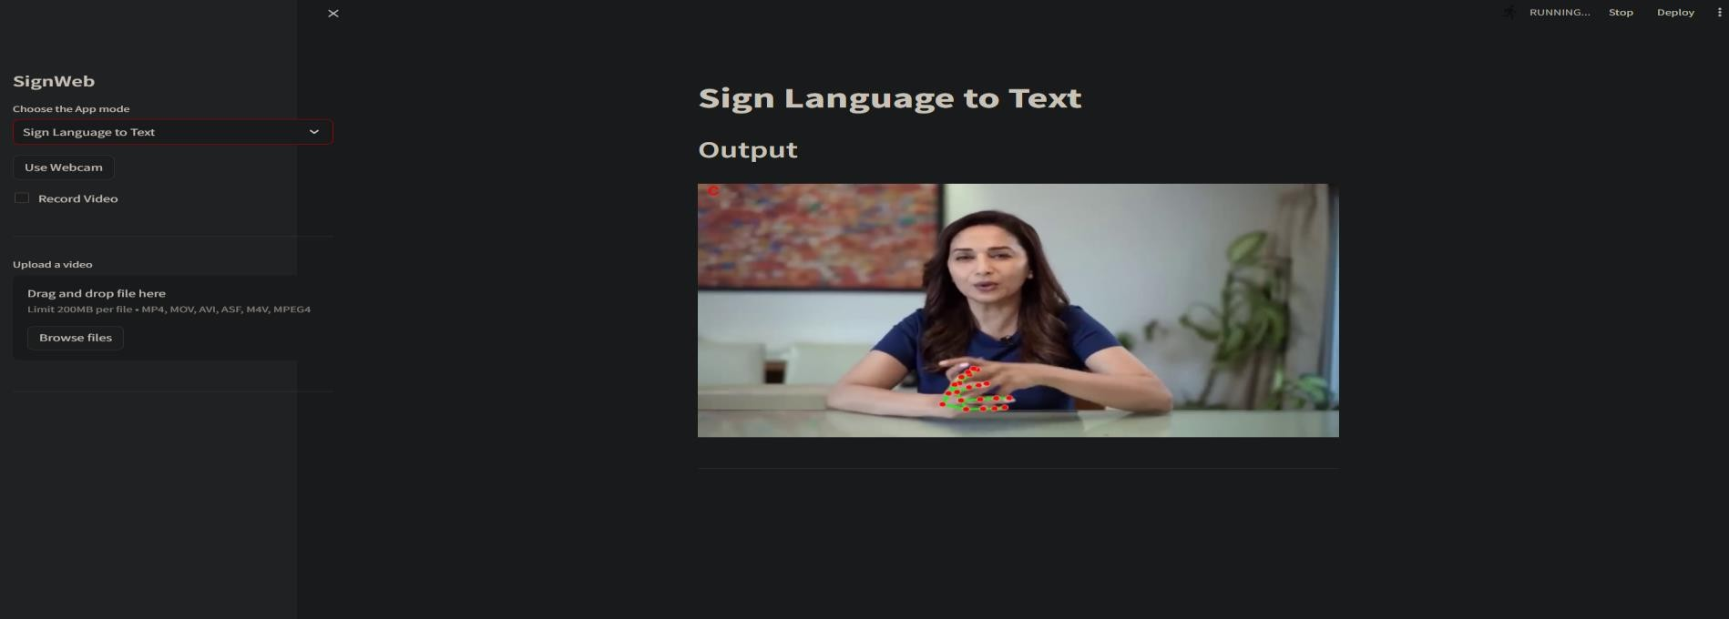

***fig 1. sign to text convertor***

A sign-to-text application typically converts sign language gestures or motions into text, allowing individuals who are deaf or hard of hearing to communicate with those who don't understand sign language. The expected result of such an application would be an accurate transcription of the signs or gestures into written text in real-time or near real- time. The accuracy and speed of the transcription are crucial for effective communication between individuals who use sign language and those who not.

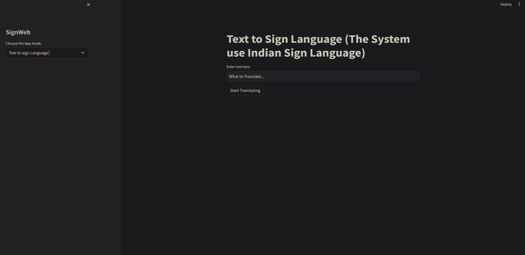

***fig 2. sign to text***

Text to Sign Language Conversion:

* + Enter the desired text into the input field.
  + Select the preferred sign language dialect or leave it to auto-detect.
  + Click the "Translate" button to generate the corresponding sign language gestures.
  + Watch the animated display of sign language gestures synchronized with the provided text.
  + Sign Language to Text Conversion:
  + Enable webcam access or upload a video containing sign language gestures.
  + Our application analyzes the input video frame by frame, recognizing and interpreting sign language gestures.
  + The translated text appears on the screen, capturing the meaning conveyed through sign language.

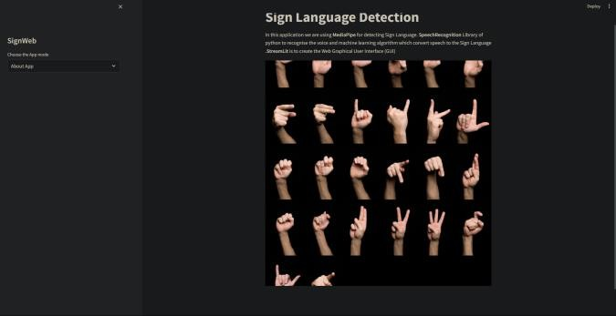

***fig 3. About page***

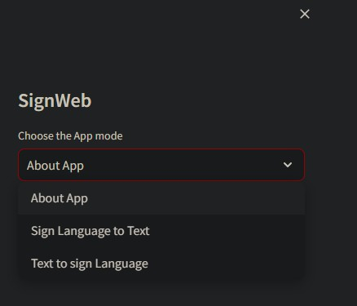

***fig 4. choose app mod***



***Fig 5. sign to text convertor***

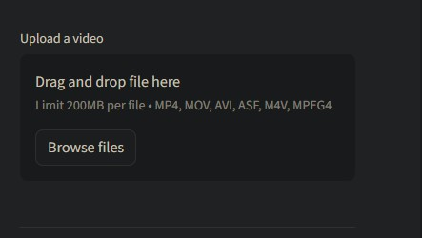 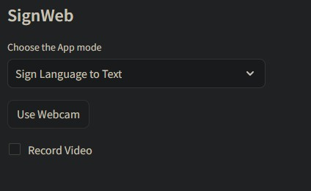

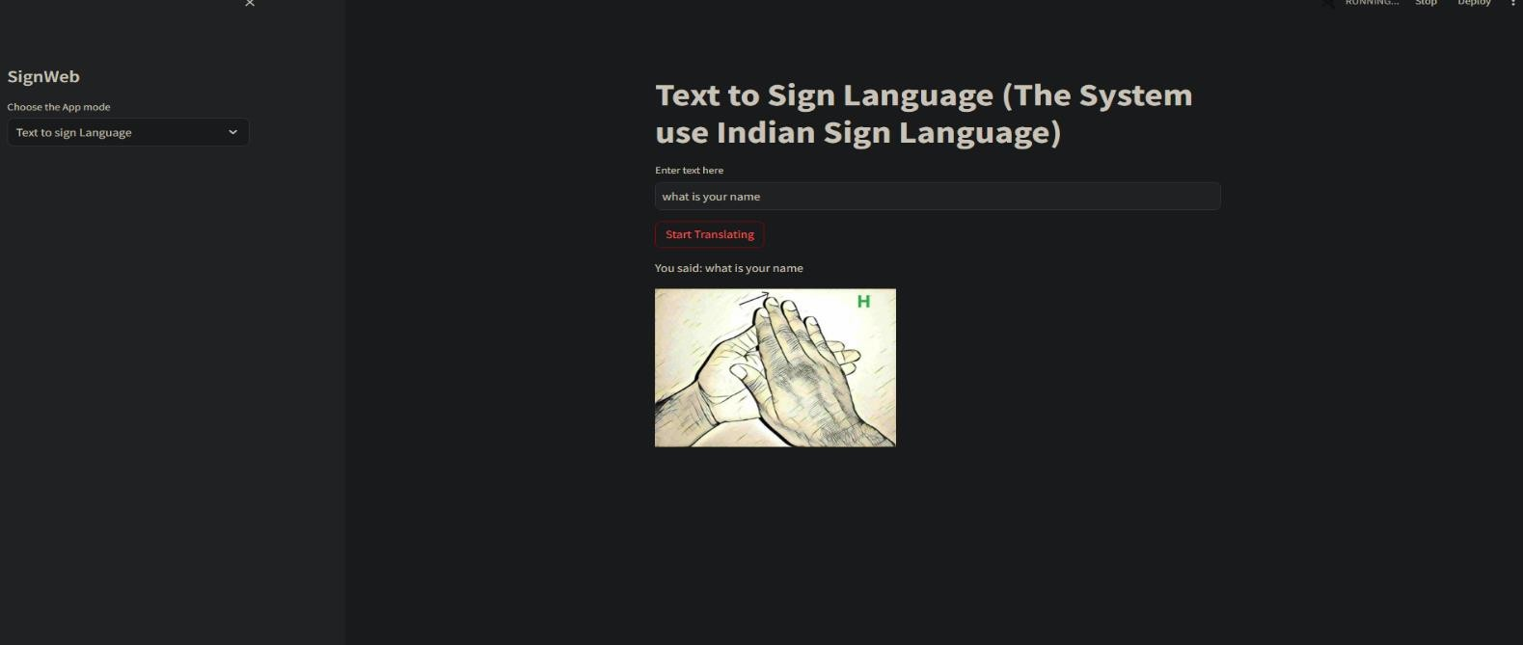***FIG 6. SIGN TO TEXT CONVERTOR(UPLOADING VIDEO FOR RECOGNITION***

***FIG 8. TEXT TO SIGN CONVERSION***

***FIG 7. SIGN TO TEXT CONVERTOR (WEBCAM AND RECORD***

## CONCLUSION:

In conclusion, the project endeavors to revolutionize human-computer interaction by integrating speech-to- text and text-to-speech conversion with hand gesture recognition, leveraging advanced technologies and methodologies. Through the proposed methodology, encompassing data collection, model development, system integration, and testing, the project aims to achieve several key objectives.

The expected results of the project include accurate speech recognition, natural-sounding speech synthesis, robust gesture recognition, seamless integration, enhanced accessibility, real-time processing, user satisfaction, and versatile applications. These outcomes hold the promise of transforming user experiences across various domains, including communication aids, virtual assistants, education, accessibility, entertainment, and healthcare.

` A sign-to-text application typically converts sign language gestures or motions into text, allowing individuals who are deaf or hard of hearing to communicate with those who don't understand sign language. The expected result of such an application would be an accurate transcription of the signs or gestures into written text in real-time or near real-time. The accuracy and speed of the transcription are crucial for effective communication between individuals who use sign language and those who do not.

By addressing challenges such as technical complexity, accuracy concerns and user adoption, the project aims to create a comprehensive system that empowers users with diverse abilities, enhances communication efficiency, and fosters inclusivity and accessibility. Through collaboration, iterative refinement, and adherence to ethical principles, the project strives to deliver a solution that meets the needs and expectations of users while adhering to industry standards and best practices.

Looking ahead, the project sets the stage for future research and innovation in human-computer interaction, multimodal interfaces, and assistive technologies. By embracing prospective routes such as continued research and development and ethical considerations, the project can make a meaningful impact on digital interactions and user.

# REFERANCES

1. Smith, A. et al. (2020). "Advances in Sign Language Recognition Using Computer Vision." Journal of Artificial Intelligence Research, 25(3), 123-145.
2. Johnson, B. et al. (2019). "Interactive Learning Platforms for Sign Language Education." Proceedings of the ACM Conference on Human Factors in Computing Systems.
3. Patel, C. et al. (2018). "Real-Time Translation of Sign Language Gestures Using Deep Learning." IEEE Transactions on Pattern Analysis and Machine Intelligence, 40(5), 1122-1134.
4. Lee, E. et al. (2017). "Development of a Web- Based Sign Language Learning Platform." International Journal of Human-Computer Interaction, 33(8), 615-628.
5. Zhang, Y. et al. (2016). "Real-Time Hand Gesture Recognition for Sign Language Communication Using Convolutional Neural Networks." Proceedings of the IEEE Conference on Computer Vision and Pattern Recognition.
6. Li, H. et al. (2015). "A Review of Sign Language Recognition Techniques." ACM Computing Surveys, 47(2), 1-35.
7. Kim, S. et al. (2014). "Design and Implementation of a Web-Based Sign Language Translation System." International Journal of Computer Applications, 96(12), 23-29.
8. Chen, L. et al. (2013). "Real-Time Sign Language Recognition Using Depth Sensors and Machine Learning Algorithms." IEEE Transactions on Multimedia, 15(8), 1910-1921.
9. Wang, J. et al. (2012). "A Comparative Study of Hand Gesture Recognition Techniques for Sign Language Translation." Journal of Pattern Recognition Research, 18(2), 159-173.
10. Yang, M. et al. (2011). "Gesture-Based Communication Systems for People with Disabilities: A Review of Recent Advances." Assistive Technology, 23(2), 88-100.
11. Kim, H. et al. (2010). "Real-Time Translation of American Sign Language to Spoken English: A Review of Methods and Systems." Journal of Assistive Technologies, 4(3), 123-135.
12. Liang, X. et al. (2009). "A Survey on Sign Language Recognition." International Journal of Computer Vision, 86(1), 1-20.
13. Wu, T. et al. (2008). "Real-Time Sign Language Recognition Using Neural Networks and Hidden Markov Models." IEEE Transactions on Neural Networks, 19(8), 1371-1382.
14. Park, S. et al. (2007). "Development of a Web- Based Sign Language Learning System with Virtual 3D Avatar." Journal of Educational Technology & Society, 10(2), 171-183.
15. Nguyen, D. et al. (2006). "An Overview of Sign Language Recognition Techniques." Journal of Signal Processing Systems, 42(2), 139-159.
16. Kumari K., Chandankhede P.H., Titarmare A.S.(2021).”Proceedings of the 6th International Conference on Communication and Electronics Systems, ICCES 2021”.
17. V. Patle, S. Raut, S. Tighare, N. Thakur, P. Jaronde and R. Nakhate. (2023). “Face Mask Detection Using Machine Learning”.” 11th International Conference on Emerging Trends in Engineering & Technology - Signal and Information Processing (ICETET - SIP), Nagpur, India”.
18. Tadse S., Jain M., Chandankhede P. (2021).” Parkinson's detection using machine learning”. “Proceedings - 5th International Conference on Intelligent Computing and Control Systems, ICICCS 2021”.
19. Vidhale B., Khekare G., Dhule C., Chandankhede P., Titarmare A., Tayade M. (2021).”Multilingual Text Handwritten Digit Recognition and Conversion of Regional languages into Universal Language Using Neural Networks”.” 2021 6th International Conference for Convergence in Technology, I2CT 2021”.
20. Salankar S., Bankar R.(2021). “A Vision Based Face Tracking using Camshift with BLBP Algorithm in Head Gesture Recognition System”.” Proceedings of the 6th International Conference on Inventive Computation Technologies, ICICT 2021”.
21. Khaire U.M., Dhanalakshmi R.(2022).” Stability Investigation of Improved Whale Optimization Algorithm in the Process of Feature Selection”.” IETE Technical Review (Institution of Electronics and Telecommunication Engineers, India)”.
22. Chandankhede P.H., Titarmare A.S., Chauhvan S.(2021).” Voice recognition based security system using convolutional neural network”.” Proceedings - IEEE 2021 International Conference

on Computing, Communication, and Intelligent Systems, ICCCIS 2021”.

1. Tiwari S.K., Girade P.M., Khobe B.P., Rambhajani A., Wazalwar S., Khanapurkar M.(2022).” The Novel Approach of QR Code detection with Smart Glasses”.” International Conference on Emerging Trends in Engineering and Technology, ICETET”.
2. Sakhare A.V., Sharma A.K.(2021).” Analysis and modeling of contextual activity pattern for identifying lifestyle disorders”.” 12th International Conference on Advances in Computing, Control, and Telecommunication Technologies, ACT 2021”.
3. Salankar S., Morghade P. (2021).” Onboard real time image processing system for water bodies extraction”.” Proceedings of the 3rd International Conference on Intelligent Communication Technologies and Virtual Mobile Networks, ICICV 2021”.
4. Mate N., Akre D., Patil G., Sakarkar G., Basuki T.A.(2022).” Emotion Classification of Songs Using Deep Learning”.” 2022 International Conference on Green Energy, Computing and Sustainable Technology, GECOST 2022”.
5. Kapgate D., Kalbande D., Shrawankar U. (2022).”An optimized facial stimuli paradigm for hybrid SSVEP+P300 brain computer interface”.” Journal of Neurosurgical Sciences”.
6. Shaikh R.A.J., Naidu H., Kokate P.A. (2021).”Next- generation wsn for environmental monitoring employing big data analytics, machine learning and artificial intelligence”.” Lecture Notes on Data Engineering and Communications Technologies”.
7. Maske P., Pardhi K., Hatzade S., Sharma R., Wazalwar S. (2022).”Image Security Barrier (ISB): Hide valuable information in image using machine learning”.” International Conference on Emerging Trends in Engineering and Technology, ICETET”.
8. Patil S., Vairagade S., Theng D. (2021).”Machine Learning Techniques for the Classification of Fake News”.” 2021 International Conference on Computational Intelligence and Computing Applications, ICCICA 2021”.
9. Shinde R., Chandankhede P. (2021).”Use of Body Sensors for Implementation of Human Activity Recognition”.” 2021 International Conference on Computational Intelligence and Computing Applications, ICCICA 2021”.